# Summary of Tablet Replacements Project, by C. Barker

## ALWSC Summary Report - Panasonic Toughpad FZ-G1

The Tablet works/supports either Windows 7 or Windows 8, which is good considering the fact that ALWSC will be moving forwards with implementing Windows 8.1 OS to all system. Demo the Tablet in USGS Windows 7 64bit form, and was able to talk with all major field equipment through the USB access port. Major hurdles to be consider are DOI polices; DAR, eRAS, IEM, and SCCM management. All of which were able to installed without any problems. Do note that system was using USGS Windows 7 64bit platform for testing DAR installation and encryption. USGS Windows 8.1 64bit would require further testing.

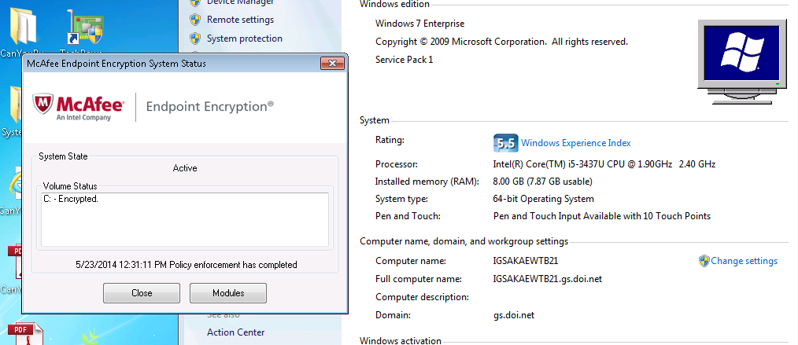

FZ-G1 model came with an Intel Core i5 3437U @ 1.90Ghz, 8GB RAM, 128GB SSD, and Intel HD Graphics 4000. The Tablet is light weight at less than 3lbs. and can be easily handle with one hand. Style’s pen is built into the model and has an attached cord to it. Recommendation is to increase the hard drive to the bigger 256GB SSD to accommodate a D:\Drive, and User’s data. There is a variety of optional interfaces that can be configure for the Tablet, but there is some limitation as to what all can be selected. Biggest Hardware requirement needed by a software program would probably be either ArcGIS or SAS. Ran test system analysis of Tablet, and return that the system can run ArcGIS above recommended hardware. Testing is being perform for SAS. Installation of SAS on system was successful, note storage consume by software was about 8GBs. The SSD is a hugh factor in the speed of the system. Boot up time is mere secs and not mins.

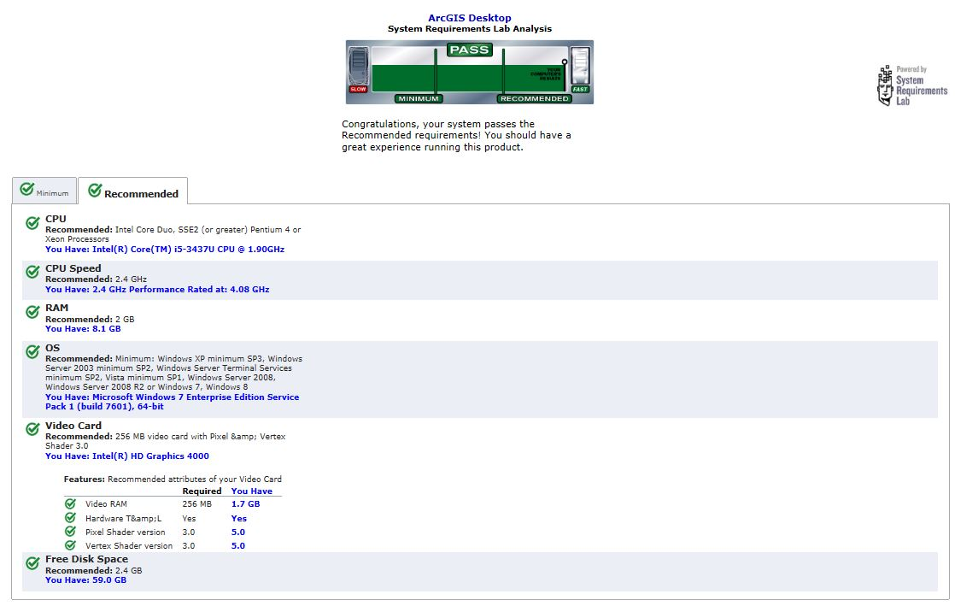 Results from “Can your computer run ArcGIS?”

Users’ testing reported back was very positive of the Tablet. Here are some of the things talked about. First impression people got was amazed at how light the Tablet was. Hand Strap was very handy and liked by Users, and liked it being built-into the system. A Left hand User’s will have to change the ordination of the display to accommodate using the digital pen. But once people got use the Tablet and made adjustments, everything was fine. Tablet can easily be viewed outdoors in the sun without any problems. Very responsive to a person’s touch and pen. The door latch for the SmartCard Reader can easily be bump open. Finger tips were naturally gripping where the latch is located. The bulkiness of SmartCard extension sticking out is a little awkward. Quality/Design of the access panel/cover to the USB and HDMI is not of the best material. Experience with other similar design (Dell E6420ATG rubber covers), Users’ will easy break/tear this part off in the future. Demo also had a screen protector applied, also recommend for Field Users. Screen size of 10” was very useable to the Users, and had little trouble select and using programs. Shoulder strap was request by User, so they can use both hands while still carrying the Tablet into the field. Fiddle with the on-board Bluetooth, more testing needed. Overall experience was positive for the Users. Recommend purchasing 3 - 4 year product replace warranty.

Some User may experience a learning curve getting use to the idea of using one’s figure or styles pen rather an using a mouse pad (Bc I have fat figures, I’ll admit that I had trouble using the virtual keyboard.). Seems there two version of a virtual keyboard on the Table. Sample experience with the Battery Life yield a power state of about 4 hours, before needing to recharge. This may be due to the fact that it’s a Demo model, and not a new one. But recommended purchasing either a warranty for the battery or the bigger longer battery Panasonic offers. Experience in the past with battery power, is to always go with the bigger model. Typical, after 2-3 years the batteries will need to be replaced anyways because of normal wear and tear. Also Tech Users now go to more than one site at a time, and often expressing the dislike of having to the shutdown and power up in-between locations. Experienced a failed restart from Hibernation, causing system to crash and reboot its self, losing Data in the process. Recommend disabling Hibernation feature of the Table, instead go straight to a Shutdown mode, when power state reaches critical levels.

The Docking Station works with the hand strap attached, which other models tested require you to take them off. Wish station had better accessories ports like; DisplayPort, more than two USB ports. Had to figure out a way to get two display panels to work. Tried every adapter combination possible. But do to the hardware limitation of the Tablet being used in the docking station, the system will only allow you to use either the VGA or the HDMI port, but not both at the same time. This was confirm by a Sales Rep. Looked into the open market for products that would support our needs, but was very limited. One product seem to fit our needs: Matrox DualHead2Go Digital Edt. VGA, testing is ongoing. But was able to get dual monitors to work thru the VGA port. While I will state that the System only see the monitors as one and not separate. And the resolution was max out at 2048 x 768 for Dell 1907fpt, so I will further test the resolution with other size monitors. I contacted the Panasonic Rep about this issue, and they are aware of the issues and currently working on a newer docking model that’s due out later next year 2015 that will correct this problem.

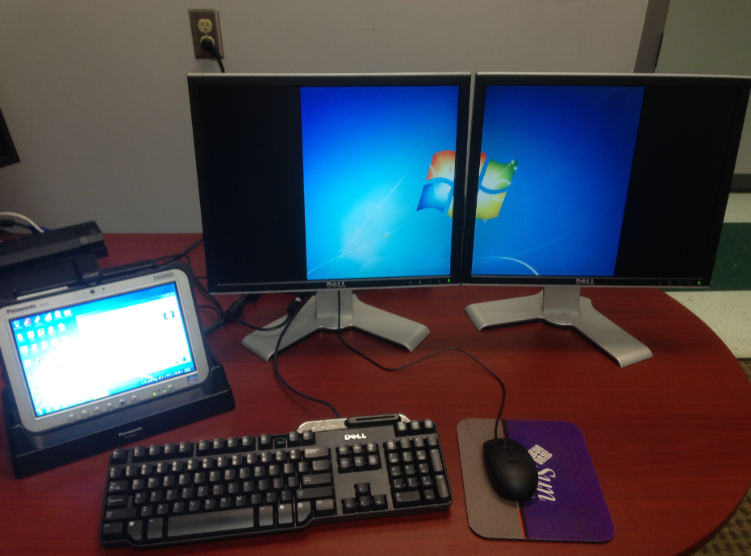

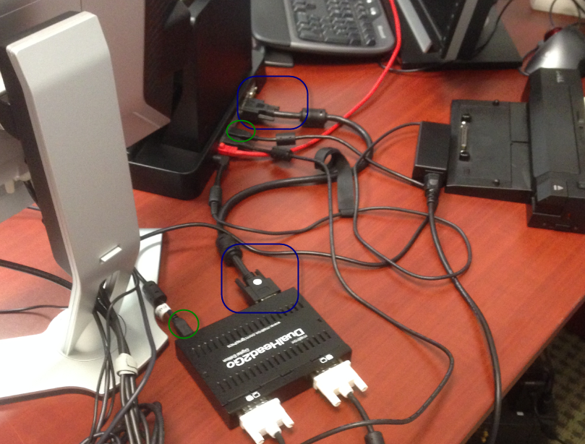

While system is docked and attempting to logon using the keyboard, I noticed a split sec delay when using the “Shift Key” + “any key”. This can lead to many failures to sign in, for people who type fast.